**INDIAN TRADITIONAL KNOWLEDGE ASSIGNMENT**

**AGRICULTURE AND WATER IN INDIA**

**PRACTICES OF SUSTAINABLE AGRICULTURE**

Sustainable agriculture is a type of agriculture that focuses on producing long-term crops and livestock without harming the environment. In other words, it is a techniques and method that protect the environment, public health, human communities and animal welfare while producing food, fibre, or plant or animal products. The list of the various methods and techniques which are used in sustainable agriculture are:

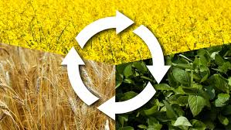**1. Crop Rotation:** Crop rotation is one of the most powerful techniques of sustainable agriculture. Its purpose is to avoid the consequences that come with planting the same crops in the same soil for years in a row. It helps tackle pest problems, as many pests prefer specific crops. If the pests have a steady food supply they can greatly increase their [population size](https://www.conserve-energy-future.com/causes-effects-solutions-of-overpopulation.php). Rotation breaks the reproduction cycles of pests. During rotation, farmers can plant certain crops, which replenish plant nutrients. These crops reduce the need for chemical fertilizers.

**2. Cover Crops:** Many farmers choose to have crops planted in a field at all times and never leave it barren, this can cause unintended consequences. By planting cover crops, such as clover or oats, the farmer can achieve his goals of preventing soil erosion, suppressing the growth of weeds, and enhancing the quality of the soil. The use of cover crops also reduces the need for chemicals such as fertilizers.

**3. Soil Enrichment:** Soil is a central component of agricultural ecosystems. Healthy soil is full of life, which can often be killed by the overuse of pesticides. Good soils can increase yields as well as creating more robust crops. It is possible to maintain and enhance the [quality of soil](https://www.conserve-energy-future.com/causes-and-effects-of-soil-pollution.php) in many ways. Some examples include leaving crop residue in the field after a harvest, and the use of composted plant material or animal manure.

**4. Natural Pest Predators:** In order to maintain effective control over pests, it is important to view the farm as an ecosystem as opposed to a factory. For example, many birds and other animals are in fact natural predators of agricultural pests. Managing your farm so that it can harbor populations of these pest predators is an effective as well as a sophisticated technique. The use of chemical pesticides can result in the indiscriminate killing of pest predators.

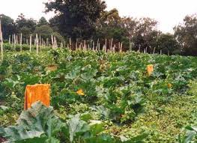**5. Bio intensive Integrated Pest Management:** Integrated pest management (IPM). This is an approach, which really relies on biological as opposed to chemical methods. IMP also emphasizes the importance of crop rotation to combat pest management. Once a pest problem is identified, IPM will mean that chemical solutions will only be used as a last resort. Instead the appropriate responses would be the use of sterile males, and biocontrol agents such as ladybirds.

## 6. ****Contour Ploughing****

This technique or method of farming prevents soil erosion such as reduced crop productivity, worsened water quality, lower an effective reservoir water levels, flooding and habitat destruction. It is different from terrace farming because in terracing wide steps are cut around the slopes. In this technique or method, the ruts are perpendicular rather than slopes made by the plough, generally resulting in furrows that curve around the land and are level.

## 7. ****No-Till Farming****

It is also known as **zero tillage or direct drilling farming**, is a way of growing crops or pasture from year to year without disturbing the soil through tillage. It is an agricultural technique or which increases the amount of water that infiltrates into the soil and increases organic matter retention and cycling of nutrients in the soil. In many agricultural regions, it can eliminate soil erosion. It increases the amount and variety of life in and on the soil, including disease causing organisms and disease suppression organisms. The most powerful benefit of no-tillage is improvement in soil biological fertility, making soils more of resilient.

**8. Drip Irrigation**

It is also known as **trickle irrigation or micro irrigation.** In this method, wateris irrigated to the roots of the plants by dripping, either onto the soil surface or directly onto the root zone, through a network of valves, pipes, tubing and emitters.

**9. Agroforestry**

It combines agricultural and forestry technologies to create more diverse, productive, profitable, healthy and sustainable land-use systems. It has a lot in common with **intercropping**. Both have two or more plant species (such as nitrogen-fixing plants) in close interaction.

## 10. Integrating crops and livestock

Plant and animal agriculture can be reintegrated in several ways. Some livestock, especially beef cattle and dairy cows, could be raised partially or entirely on pastures, which (when well managed and not overstocked) would reduce soil erosion, increase soil fertility, store carbon, and provide habitat for beneficial organisms. Pasture-raised livestock also require fewer antibiotics than those raised in CAFOs, reducing their contribution to the spread of antibiotic-resistant disease. Furthermore, pasture-based and other integrated livestock operations offer midwestern farmers the opportunity to meet rising consumer demand for healthy, humane, grass-fed, and sustainably raised meats and milk.

Crop and livestock reintegration can be accomplished on a regional basis or on individual farms; distributing animal operations throughout the Midwest would produce a range of benefits, from reduced nutrient pollution to enhanced soil fertility. And integrated livestock production would support local markets for forage crops such as alfalfa, helping to facilitate longer crop rotations and conservation practices in the region.

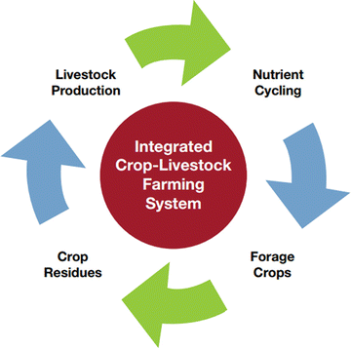

**CAN ORGANIC FARMING SUSTAIN INDIAN AGRICULTURE?**

The slow growth of agricultural production in India can be attributed to an inefficient rural transport system, lack of awareness about the treatment of crops, limited access to modern farming technology and the shrinking agricultural land due to urbanization

The good news is that experience in India and other countries shows that the adoption of sustainable farming practices can increase both productivity and reduce ecological harm.

Sustainable agriculture techniques enable higher resource efficiency – they help produce greater agricultural output while using lesser land, water and energy, ensuring profitability for the farmer. These essentially include methods that, among other things, protect and enhance the crops and the soil, improve water absorption and use efficient seed treatments. While Indian farmers have traditionally followed these principles, new technology now makes them more effective.

For example, for soil enhancement, certified biodegradable mulch films are now available. A mulch film is a layer of protective material applied to soil to conserve moisture and fertility. Most mulch films used in agriculture today are made of polyethylene (PE), which has the unwanted overhead of disposal. It is a labour intensive and time-consuming process to remove the PE mulch film after usage. If not done, it affects soil quality and hence, crop yield.

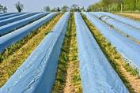

The other perpetual challenge for India’s farms is the availability of water. Many food crops like rice and sugarcane have a high-water requirement. In a country like India, where majority of the agricultural land is rain-fed, low rainfall years can wreak havoc for crops and cause a slew of other problems - a surge in crop prices and a reduction in access to essential food items. Again, Indian farmers have long experience in water conservation that can now be enhanced through technology.

In addition to soil and water management, the third big factor, better seed treatment, can also significantly improve crop health and boost productivity. These solutions include application of fungicides and insecticides that protect the seed from unwanted fungi and parasites that can damage crops or hinder growth and increase productivity.

**ORGANIC / ECO-FRIENDLY FARMING**

The introduction of chemicals in farming got many delirious at the sight of what they could accomplish. Yields exploded. At the start, the soil was healthy. Any damage brought about by chemical fertilizers was hardly noticeable. Pests had not developed resistance to the chemicals. The technology spread across the world as it was considered the revolution in agriculture.

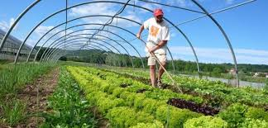Flash forward to today, and many people are marvelling at [organic farming](https://www.conserve-energy-future.com/pros-and-cons-organic-farming.php) again. This is after learning that conventional farming methods come with a host of problems including health-related diseases like cancer, [pollution](https://www.conserve-energy-future.com/causes-effects-solutions-to-smog-pollution.php), [degradation of soil](https://www.conserve-energy-future.com/causes-effects-solutions-soil-degradation.php) and water, and impact on domestic animals.

[Organic farming is a technique](https://www.conserve-energy-future.com/organic-farming-need-and-features.php), which involves the cultivation of plants and rearing of animals in natural ways. This process involves the use of biological materials, avoiding synthetic substances to maintain soil fertility and ecological balance thereby minimizing [pollution](https://www.conserve-energy-future.com/causes-effects-of-industrial-pollution.php) and wastage.

In other words, organic farming is a farming method that involves growing and nurturing crops without the use of synthetic based fertilizers and pesticides. Also, no [genetically modified organisms](https://www.conserve-energy-future.com/pros-cons-gmos.php) are permitted.

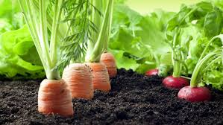It relies on ecologically balanced agricultural principles like [crop rotation](https://www.conserve-energy-future.com/advantages-disadvantages-crop-rotation.php), green manure, organic waste, biological pest control, mineral and rock additives. Organic farming makes use of pesticides and fertilizers if they are considered natural and avoids the use of various petrochemical fertilizers and pesticides.

Differences Between Organic and Conventional Farming Methods

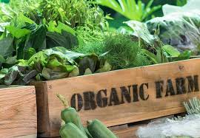In the conventional farming methods, before seeds are sown, the farmer will have to treat or fumigate his farm using harsh chemicals to exterminate any naturally existing fungicides. He will fertilize the soil using petroleum-based fertilizers. On the flip side, the organic farmer will prepare and enrich his land before sowing by sprinkling natural-based fertilizers such as manure, bone meal or shellfish fertilizer.

Before planting seeds, the organic farmer will soak the seeds in fungicides and pesticides to keep insects and pests at bay. Chemical are also incorporated in the irrigation water to prevent insects from stealing the planted seeds.

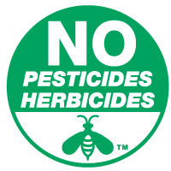On the other hand, the organic farmer will not soak his seeds in any chemical solution nor irrigate the newly planted seeds using water with added chemicals. In fact, he will not even irrigate with council water, which is normally chlorinated to kill any bacteria. He will depend on natural rain or harvest and [stored rainwater](https://www.conserve-energy-future.com/methods-of-rainwater-harvesting.php) to use during dry months.

When the seeds have sprung up, and it’s time to get rid of weeds, the conventional farmer will use weedicide to exterminate weeds. However, he will physically weed out the farm, although it’s very labor-intensive. Better still, the organic farmer can use a flame weeder to exterminate weeds or use animals to eat away the weeds.

**Reasons For Organic Farming**

The [population of the planet](https://www.conserve-energy-future.com/causes-effects-solutions-of-overpopulation.php) is skyrocketing and providing food for the world is becoming extremely difficult. The need of the hour is sustainable cultivation and production of food for all.

The Green Revolution and its chemical-based technology are losing its appeal as dividends are falling and returns are unsustainable. [Pollution](https://www.conserve-energy-future.com/causes-and-effects-of-soil-pollution.php) and [climate change](https://www.conserve-energy-future.com/various-climate-change-facts-php) are other negative externalities caused by the use of fossil fuel based chemicals.

In spite of our diet choices, organic food is the best choice you’ll ever make, and this means embracing organic farming methods. Here are the reasons why we [need to take up organic farming methods](https://www.conserve-energy-future.com/organic-farming-need-and-features.php):

### 1. To Accrue the Benefits of Nutrients

Foods from organic farms are loaded with nutrients such as vitamins, enzymes, minerals and other micro-nutrients compared to those from conventional farms. This is because organic farms are managed and nourished using [sustainable practices](https://www.conserve-energy-future.com/sustainable-practices-waste-management.php). In fact, some past researchers collected and tested vegetables, fruits, and grains from both organic farms and conventional farms.

The conclusion was that food items from [organic farms](https://www.conserve-energy-future.com/start-an-organic-garden.php) had way more nutrients than those sourced from commercial or conventional farms. The study went further to substantiate that five servings of these fruits and vegetables from organic farms offered sufficient allowance of vitamin C. However, the same quantity of fruits and vegetables did not offer the same sufficient allowance.

### 2. Stay Away From GMOs

Statistics show that genetically modified foods (GMOs) are contaminating natural foods sources at real scary pace, manifesting grave effects beyond our comprehension. What makes them a great threat is they are not even labelled. So, sticking to organic foods sourced from veritable sources is the only [way to mitigate these grave effects](https://www.conserve-energy-future.com/25-effective-ways-to-improve-indoor-air-quality.php) of GMOs.

### 3. Natural and Better Taste

Those that have tasted organically farmed foods would attest to the fact that they have a natural and better taste. The natural and superior taste stems from the well balanced and nourished soil. Organic farmers always prioritize quality over quantity.

### 4. Direct Support to Farming

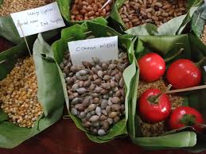Purchasing food items from organic farmers is a sure-fire investment in a cost-effective future. Conventional farming methods have enjoyed great subsidies and tax cuts from most governments over the past years. This has led to the proliferation of commercially produced foods that have increased dangerous diseases like cancer.

It’s time governments invested in organic farming technologies to mitigates these problems and secure the future. It all starts with you buying food items from known organic sources.

### 5. To Conserve Agricultural Diversity

These days, it normal to hear news about [extinct species](https://www.conserve-energy-future.com/15-extraordinary-extinct-species.php) and this should be a major concern. In the last century alone, it is approximated that 75 percent of the [agricultural diversity](https://www.conserve-energy-future.com/pros-and-cons-of-organic-agriculture.php) of crops has been wiped out. Slanting towards one form of farming is a recipe for disaster in the future. A classic example is a potato. There were different varieties available in the marketplace. Today, only one species of potato dominate.

### 6. To Prevent Antibiotics, Drugs, and Hormones in Animal Products

Commercial dairy and meat are highly susceptible to contamination by dangerous substances. A statistic in an American journal revealed that over 90% of chemicals the population consumes emanate from meat tissue and dairy products.

According to a report by Environmental Protection Agency (EPA), a vast majority of pesticides are consumed by the population stem from poultry, meat, eggs, fish and dairy product since animals and birds that produce these products sit on top of the food chain.

This means they are fed foods loaded with chemicals and toxins. Drugs, antibiotics, and growth hormones are also injected into these animals and so, are directly transferred to meat and dairy products. Hormone supplementation fed to farmed fish, beef and dairy products contributes mightily to the ingestion of chemicals. These chemicals only come with a lot of complications like genetic problems, cancer risks, growth of tumour and other complications at the outset of puberty.

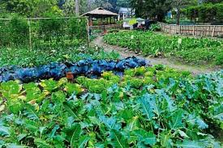

**HOW WERE ANCIENT AGRICULTURAL METHODS ECO-FRIENDLY?**

Pre-industrial traditional or ancient agriculture was nothing but conservation agriculture (CA) in which farmers developed thousands of crop varieties and animal breeds over centuries through natural crossing (hybridization) and selection, and crop and variety adaptation to local soil, biotic, climatic (drought, flood, storms) and social conditions. Soil fertility was regenerated through long periods of rest (fallowing, 10-15 years), periodic addition of natural materials such as household wastes, composts and manures, and adopting practices such as crop rotations (especially with N-fixing legumes) and mixed planting. Additional N for agriculture was obtained from mining of Chilean saltpetre and Peruvian guano deposits and extraction of ammonium compounds from coal. Farmers replanted their own seeds and exchanged their seeds and animal breeds with others, thereby spreading new planting materials and animal breeds far and wide and thus preserving biodiversity in farmlands. This form of ancient agriculture supported the small population existing during those times, and all living organisms including humans lived in harmony with nature.

However, with the rapidly increasing food demand to support the exploding population during and after the 20th century, it was necessary to intensify agriculture with new crop varieties, fertilizers and pesticides, and irrigation—collectively called the Green Revolution (GR). Despite the impressive records of food production, avoidance of hunger and famine, there are reports of certain adverse effects such as resource depletion and degradation, environmental pollution, loss of biodiversity. Thus, the need for a new form of intensive CA that could produce enough food, feed, fibre, and fuel for the large and growing population with minimum impact on the resource base and environment arose.

Hence comes the stemming of the criticism of modern agricultural practices which employ substances that are proven to be harmful to the human body and has led to an uproar of scepticism with regard to consumption of its direct products inclusive of but not restricted to fruits such as apples, guavas, pears and so on and so forth. Modern agriculture vis-a-vis orthodox practices have hence earned a reputation of a double ended sword wherein the efficiency has substantially been shot up while the downsides have been extended beyond a few bad fruits and vegetables.

The self-sustaining cycle of orthodox practices can be easily visualized and leaves no room for concern as to its adverse effects on nature.

Brief accounts as detailed below of ancient practices should enable a better perspective as to their simplicity.

**Ancient Agriculture in the Vedic Period**

There are repeated references to iron in the later Vedic texts (BC. 1000–500 BC). Cultivation of a wide range of cereals, vegetables, and fruits is described in the text. Meat and milk products were part of the diet; animal husbandry was important. The soil was ploughed several times. The importance of seeds was emphasised and a certain sequence of cropping were recommended. Cow dung provided the manure and irrigation was practiced was during this time.

**Ancient Agriculture in the Mauryan Empire**

The Mauryan Empire (322–185 BCE) categorized soils and made meteorological observations for the agricultural use. Other Mauryan facilitation included construction and maintenance of dams and provision of horse-drawn chariots—that was quicker than traditional bullock carts. The Greek diplomat Megasthenes (300 BC) in his book Indika provides an eyewitness account of Indian agriculture at that time. He writes, “India has many huge mountains which abound in fruit-trees of every kind, and many vast plains of great fertility. The greater part of the soil is under irrigation, and consequently bears two crops in the course of the year. In addition to cereals, there grows millet, and different sorts of pulse and rice throughout India. Since there are two monsoons in the course of each year the inhabitants gather in two harvests annually.

**ECO-FRIENDLY APPROACHES FOR FARMING SYSTEM**

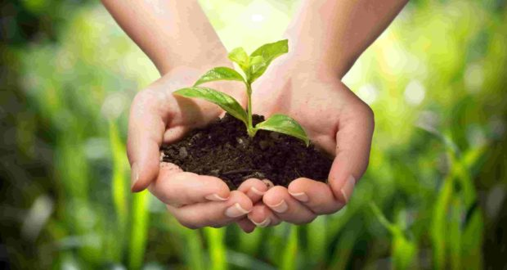World needs, eco-friendly farming systems for sustainable agriculture. This is the need of the present day. There is an urgent need to develop farming techniques, which are sustainable from environmental, production, and socioeconomic points of view. The means to guarantee sufficient food production in the next decades and beyond is critical because modern agriculture production throughout the world does not appear to be sustainable in the long-term. The agricultural community is thus setting it hopes on sustainable agriculture, which will maintain the cycles of input-output and ecosystem balance.

**1. Limiting Farmland Expansion**

Plant science allows farmers to grow more food on existing farmland. 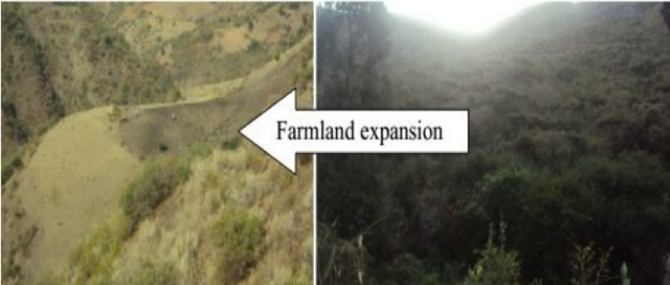

For example, if biotech crops had not been available to the 17.3 million farmers using it in 2012, maintaining global production levels would have required cultivating:

* An extra 4.9 million hectares of land for soybeans,
* An extra 6.9 million hectares of land for corn,
* An extra 3.1 million hectares of land for cotton, and,
* An extra 0.2 million hectares of land for canola.

Altogether, since 1992 biotech crops have saved farmland expansion of 132 million hectares.

**2. Preserving biodiversity**

Advances in crop protection have allowed farmers to make the most of existing cropland and curb expanding acres into biodiverse areas. Between 35 and 42 per cent of the world’s potential crop production is lost annually due to weeds, insects, diseases and other pests. These losses would double without crop protection products, forcing farmers cultivate more land.

**3. Reducing greenhouse gases**

Plant biotechnology and crop protection products have helped farmers significantly cut their greenhouse gas emissions to mitigate climate change. Herbicide tolerant crops facilitate no-till farming which leaves soil undisturbed and keeps carbon in the ground. In 2013 alone, this helped reduce CO2 emissions by 28 billion kilograms – equivalent to taking 12.4 million cars off the road for one year.

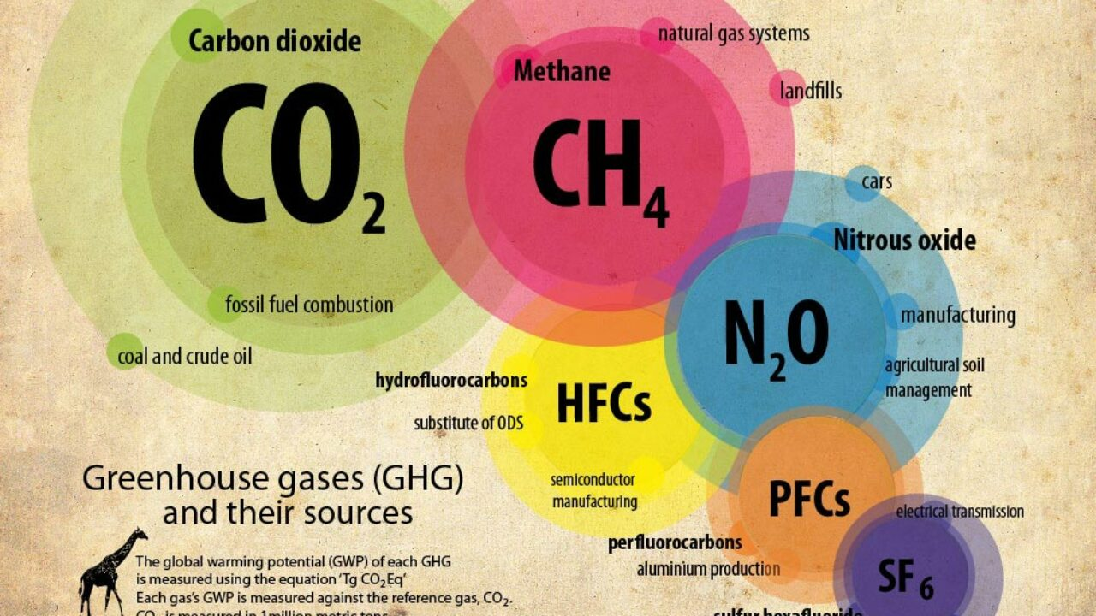

**4. Conserving water**

Water shortages are a constant threat to farmers in Africa. The Food and Agriculture Organization of the United Nations estimates that by 2025 approximately 480 million people in Africa could be living in areas of water scarcity. To prepare for this challenge, plant scientists are researching drought tolerant traits to use water more efficiently. For example, the [Water-Efficient Maize for Africa](http://wema.aatf-africa.org/about-wema-project) (WEMA) project is developing ways to double maize yields through conventional and marker-assisted breeding and plant biotechnology.

**5. Using Renewable Energy Resources**

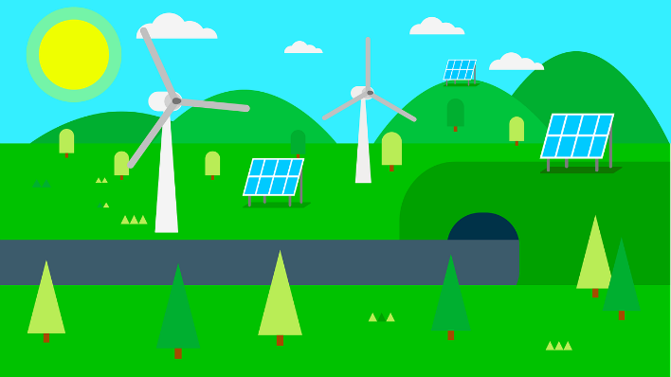Sustainable farming involves the use of alternative energy sources such as hydropower, solar power or wind farms which are eco-friendly. SOLAR PANELS can be used to run pumping and heating systems. Also, hydroelectric power sourced from river water can be used for various farming machinery.

**6. Protecting soil**

Up to 50,000 square kilometers of soil (about the size of Costa Rica) is lost every year to soil erosion and the world’s agriculture industry is working hard to stop this trend. Sustainable farming practices such as no-till help preserve our soil and reduce erosion. In Canada, for example, farmers who planted herbicide-tolerant canola and used no-till techniques reduced soil erosion by 86 percent.

*Sustainable farming is the key to a better tomorrow. Promoting sustainability across the farming value chain guarantees increased food production capacities and active environmental protection. It's farming for a better tomorrow.*

**IMPORTANT WATER RESOURCES OF INDIA**

**Rivers**

In India, rivers have been the lifelines of growth and culture. India is drained by twelve major river systems with a number of smaller rivers and streams. Major river systems in the north are the perennial Himalayan rivers – Ganga, Yamuna, Indus and Brahmaputra. The south has the non-perennial but rain fed Krishna, Godavari, and Cauvery while central India has the Narmada, Mahanadi and Tapti.

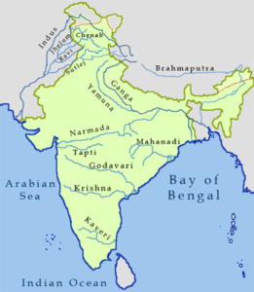

**Lakes**

Apart from rivers, India is house to some of the most beautiful lakes of the world, some natural, others artificial. They are there in the high Himalayas under the ice sheath, in the virgin northeast, semi-arid deserts of Rajasthan, coastal zones, or in metros, small towns and villages.

**Groundwater aquifers**

Regarding groundwater aquifers, in India, the mountainous regions of the north and west do not allow adequate infiltration and thus, groundwater availability is mostly limited to valleys and other low-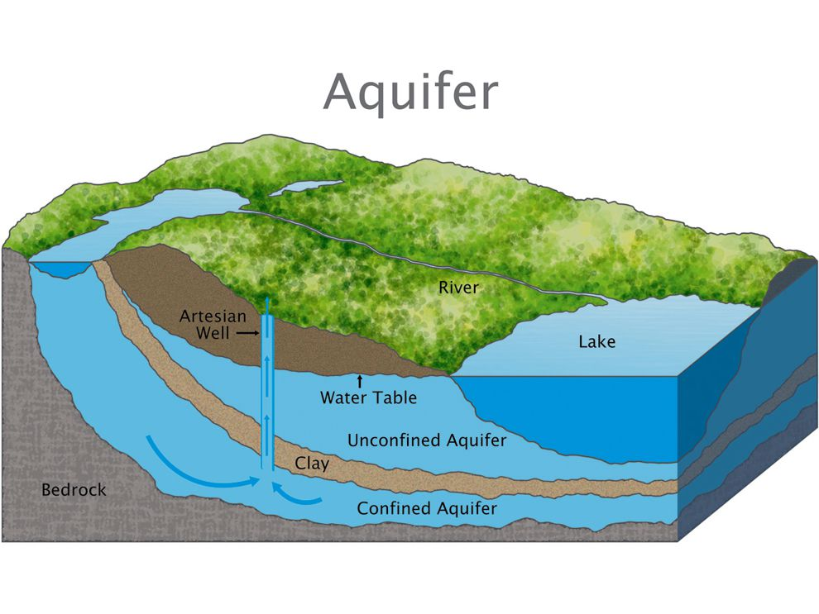lying areas. In peninsular India, the underlying geology limits the formation of large continuous aquifers. The overall yield potential in this region is low although some areas may see medium to high potential depending on the local hydro geology. Coastal regions are rich in groundwater owing to the largely alluvial terrain, but the aquifers risk being contaminated by saltwater ingress due to over pumping.

**Conclusion**

The state of India’s water systems hangs in balance. It can either revive back to sustained system or plunge downhill. In a nutshell, the biggest threats faced by the aquatic ecosystem in India include over abstraction and river flow regulation, increasing pollution, encroachment and land use, degradation of watersheds, invasion by alien species, limited efforts at conservation and rising sectoral conflicts.

**EARLY WATER STORAGE METHODS IN TAMIL NADU**

Every village in Tamil Nadu had three water bodies: one for irrigation, one for cattle and an Oorani (pond) for drinking water. All three are rain-fed. Many villages have survived centuries because of these catchment bodies.

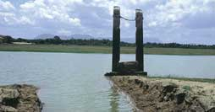**ERI**  
Approximately one-third of the irrigated area of Tamil Nadu is watered by eris (tanks). Eris have played several important roles in maintaining ecological harmony as flood-control systems, preventing soil erosion and wastage of runoff during periods of heavy rainfall, and recharging the groundwater in the surrounding areas. The presence of eris provided an appropriate micro-climate for the local areas. Without eris, paddy cultivation would have been impossible.

Till the British arrived, local communities maintained eris. Historical data from Chengalpattu district, for instance, indicates that in the 18th century about 4-5 per cent of the gross produce of each village was allocated to maintain eris and other irrigation structures.  
The early British rule saw disastrous experiments with the land tenure system in quest for larger land revenues. The enormous expropriation of village resources by the state led to the disintegration of the traditional society, its economy and polity. Allocations for maintenance of eris could no longer be supported by the village communities, and these extraordinary water harvesting systems began to decline.

**KANMOIS**  
Kanmois are traditional tanks with earthen bunds constructed many centuries ago. They are large surface water stores that collected and stored surface water run-offs. They largely supported and were used for agricultural purposes as well as for drinking water.

**KORAMBUS**  
Korambu is a temporary dam stretching across the mouth of channels, made of brushwood, mud and grass. It is constructed by horizontally fixing a strong wooden beam touching either banks of the canal. A series of vertical wooden beams of appropriate height is erected with their lower ends resting firmly on the ground and the other ends tied to the horizontal beam. Closely knitted or matted coconut thatch is tied to this frame. A coat of mud is applied to the matted frame. A layer of grass is also applied carefully which prevents dissolution of the applied mud. Korambu is constructed to raise the water level in the canal and to divert the water into field channels. It is so built that excess water flows over it and only the required amount of water flows into the diversion channels. The height of the Korambu is so adjusted that the fields lying on the upstream are not submerged. Water is allowed to flow from one field to another until all the field are irrigated. They are built twice a year especially before the onset of the monsoon season in order to supply water during winter and summer season. In Kasargod and Thrissur districts of Kerala, Korambu is known as chira.

**OORANIS**

Ooranis are small ponds that have collected rainwater from rains and from surrounding catchment areas. These Ooranis traditionally were used for various needs of drinking, washing, bathing needs of the villages around it.

Oorani is a Tamil word meaning village pond Ooranis were usually endowed by ruling or merchant princes. Beneficiaries were involved in excavation and maintenance. They developed a sense of ownership. After Independence the government departments took over every aspect of village management and Ooranis fell to neglect.

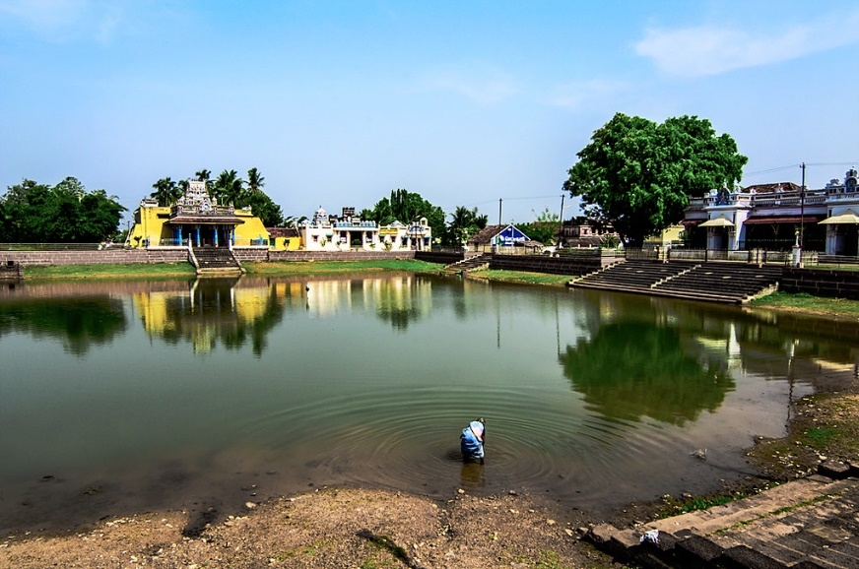

**WHERE DOES INDIA’S WATER COME FROM?**

Water Resources of India India accounts for about 2.45 per cent of world’s surface area, 4 per cent of the world’s water resources and about 16 per cent of world’s population. The total water available from precipitation in the country in a year is about 4,000 cubic km. The availability from surface water and replenishable groundwater is 1,869 cubic km. Out of this only 60 per cent can be put to beneficial uses. Thus, the total utilisable water resource in the country is only 1,122 cubic km.

● **Surface Water Resources : -** There are four major sources of surface water. These are rivers, lakes, ponds, and tanks. In the country, there are about 10,360 rivers and their tributaries longer than 1.6 km each. The mean annual flow in all the river basins in India is estimated to be 1,869 cubic km. However, due to topographical, hydrological and other constraints, only about 690 cubic km (32 per cent) of the available surface water can be utilised. Water flow in a river depends on size of its catchment area or river basin and rainfall within its catchment area. Precipitation in India has very high spatial variation, and it is mainly concentrated in Monsoon season.

Some of the rivers in the country like the Ganga, the Brahmaputra, and the Indus have huge catchment areas. Given that precipitation is relatively high in the catchment areas of the Ganga, the Brahmaputra and the Barak rivers, these rivers, although account for only about one-third of the total area in the country, have 60 per cent of the total surface water resources. Much of the annual water flow in south Indian rivers like the Godavari, the Krishna, and the Kaveri has been harnessed but it is yet to be done in the Brahmaputra and Ganga basins.

● **Groundwater Resources** : - The total replenishable groundwater resources in the country are about 432 cubic km. Table 6.1 shows that the Ganga and the Brahamaputra basins, have about 46 per cent of the total replenishable groundwater resources. The level of groundwater utilisation is relatively high in the river basins lying in north-western region and parts of south India. The groundwater utilisation is very high in the states of Punjab, Haryana, Rajasthan, and Tamil Nadu. However, there are States like Chhattisgarh, Odisha, Kerala, etc., which utilise only a small proportion of their groundwater potentials. States like Gujarat, Uttar Pradesh, Bihar, Tripura and Maharashtra are utilising their ground water resources at a moderate rate. If the present trend continues, the demands for water would need the supplies. And such a situation would be detrimental to development and can cause social upheaval and disruptions.

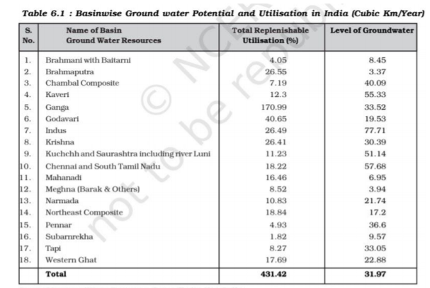

● L**agoons and Backwaters : -** India has a vast coastline and the coast is very indented in some states. Due to this, a number of lagoons and lakes have formed. The States like Kerala, Odisha and West Bengal have vast surface water resources in these lagoons and lakes. Although, water is generally brackish in these water-bodies, it is used for fishing and irrigating certain varieties of paddy crops, coconut, etc.

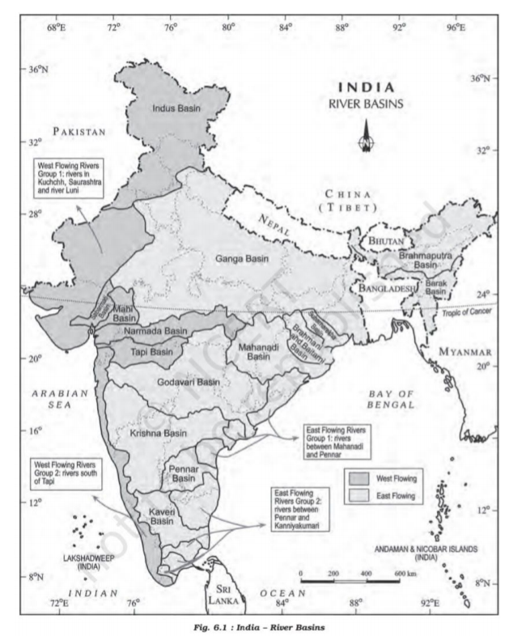

**AQUIFER**

An **aquifer** is an underground layer of [water](https://en.wikipedia.org/wiki/Water)-bearing [permeable rock](https://en.wikipedia.org/wiki/Permeability_(Earth_sciences)), rock fractures or unconsolidated materials ([gravel](https://en.wikipedia.org/wiki/Gravel), [sand](https://en.wikipedia.org/wiki/Sand), or [silt](https://en.wikipedia.org/wiki/Silt)). [Groundwater](https://en.wikipedia.org/wiki/Groundwater) can be extracted using a water [well](https://en.wikipedia.org/wiki/Well). The study of water flow in aquifers and the characterization of aquifers is called [hydrogeology](https://en.wikipedia.org/wiki/Hydrogeology). Related terms include **aquitard**, which is a bed of low permeability along an aquifer, and **aquiclude** (or *aquifuge*), which is a solid, impermeable area underlying or overlying an aquifer, the pressure of which could create a confined aquifer.

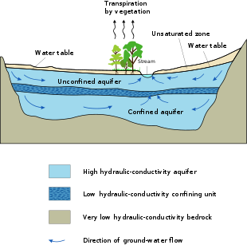

* **OCCURRENCE**

Aquifers occur from near surface to deeper than 9,000 metres (30,000 ft). Those closer to the surface are not only more likely to be used for water supply and irrigation, but are also more likely to be topped up by the local rainfall. Many desert areas have limestone hills or mountains within them or close to them that can be exploited as groundwater resources. Part of the [Atlas Mountains](https://en.wikipedia.org/wiki/Atlas_Mountains) in North Africa, the [Lebanon](https://en.wikipedia.org/wiki/Mount_Lebanon) and [Anti-Lebanon](https://en.wikipedia.org/wiki/Anti-Lebanon) ranges between Syria and Lebanon, the [Jebel Akhdar](https://en.wikipedia.org/wiki/Jebel_Akhdar_(Oman)) in Oman, parts of the [Sierra Nevada](https://en.wikipedia.org/wiki/Sierra_Nevada_(U.S.)) and neighboring ranges in the [United States' Southwest](https://en.wikipedia.org/wiki/Southwestern_United_States), have shallow aquifers that are exploited for their water. [Overexploitation](https://en.wikipedia.org/wiki/Overexploitation) can lead to the exceeding of the practical sustained yield; i.e., more water is taken out than can be replenished.

* **CLASSIFICATION**

An *aquitard* is a zone within the Earth that restricts the flow of groundwater from one aquifer to another. An aquitard can sometimes, if completely impermeable, be called an *aquiclude* or *aquifuge*. Aquitards are composed of layers of either [clay](https://en.wikipedia.org/wiki/Clay) or non-porous rock with low [hydraulic conductivity](https://en.wikipedia.org/wiki/Hydraulic_conductivity).

**Saturated versus unsaturated**

Groundwater can be found at nearly every point in the Earth's shallow subsurface to some degree, although aquifers do not necessarily contain [fresh water](https://en.wikipedia.org/wiki/Fresh_water). The Earth's crust can be divided into two regions: the [*saturated*](https://en.wikipedia.org/wiki/Water_content)*zone* or [*phreatic*](https://en.wikipedia.org/wiki/Phreatic)*zone* (e.g., aquifers, aquitards, etc.), where all available spaces are filled with water, and the *unsaturated zone* (also called the [vadose zone](https://en.wikipedia.org/wiki/Vadose_zone)), where there are still pockets of air that contain some water, but can be filled with more water.

*Saturated* means the pressure head of the water is greater than [atmospheric pressure](https://en.wikipedia.org/wiki/Atmospheric_pressure) (it has a gauge pressure > 0). The definition of the water table is the surface where the [pressure head](https://en.wikipedia.org/wiki/Hydraulic_head) is equal to atmospheric pressure (where gauge pressure = 0).

*Unsaturated* conditions occur above the water table where the pressure head is negative (absolute pressure can never be negative, but gauge pressure can) and the water that incompletely fills the pores of the aquifer material is under [suction](https://en.wikipedia.org/wiki/Suction). The [water content](https://en.wikipedia.org/wiki/Hydrogeology#Water_content) in the unsaturated zone is held in place by surface [adhesive forces](https://en.wikipedia.org/wiki/Adhesion) and it rises above the water table (the zero-[gauge-pressure](https://en.wikipedia.org/wiki/Hydrogeology#Hydraulic_head)[isobar](https://en.wikipedia.org/wiki/Contour_line#Barometric_pressure)) by [capillary action](https://en.wikipedia.org/wiki/Capillary_action) to saturate a small zone above the phreatic surface (the [capillary fringe](https://en.wikipedia.org/wiki/Capillary_fringe)) at less than atmospheric pressure. This is termed tension saturation and is not the same as saturation on a water-content basis. Water content in a capillary fringe decreases with increasing distance from the phreatic surface.

### Aquifers versus aquitard

Aquifers are typically saturated regions of the subsurface that produce an economically feasible quantity of water to a well or [spring](https://en.wikipedia.org/wiki/Spring_(hydrosphere)) (e.g., sand and [gravel](https://en.wikipedia.org/wiki/Gravel) or fractured [bedrock](https://en.wikipedia.org/wiki/Bedrock) often make good aquifer materials).

An aquitard is a zone within the Earth that restricts the flow of groundwater from one aquifer to another. A completely impermeable aquitard is called an *aquiclude* or *aquifuge*. Aquitards comprise layers of either clay or non-porous rock with low [hydraulic conductivity](https://en.wikipedia.org/wiki/Hydraulic_conductivity).

### Isotropic versus anisotropic

In [isotropic](https://en.wikipedia.org/wiki/Isotropy) aquifers or aquifer layers the hydraulic conductivity (K) is equal for flow in all directions, while in [anisotropic](https://en.wikipedia.org/wiki/Anisotropy) conditions it differs, notably in horizontal (Kh) and vertical (Kv) sense.

Semi-confined aquifers with one or more aquitards work as an anisotropic system, even when the separate layers are isotropic, because the compound Kh and Kv values are different (see [hydraulic transmissivity](https://en.wikipedia.org/wiki/Transmissibility_(fluid)) and [hydraulic resistance](https://en.wikipedia.org/wiki/Hydraulic_conductivity#Resistance)).

### Porous versus karst

Porous aquifers typically occur in sand and [sandstone](https://en.wikipedia.org/wiki/Sandstone). Porous aquifer properties depend on the [depositional sedimentary environment](https://en.wikipedia.org/wiki/Depositional_environment) and later natural cementation of the sand grains. The environment where a sand body was deposited controls the orientation of the sand grains, the horizontal and vertical variations, and the distribution of shale layers. Even thin shale layers are important barriers to groundwater flow. All these factors affect the [porosity](https://en.wikipedia.org/wiki/Porosity) and [permeability](https://en.wikipedia.org/wiki/Permeability_(earth_sciences)) of sandy aquifers. Sandy deposits formed in [shallow marine environments](https://en.wikipedia.org/wiki/Shallow_water_marine_environment) and in [windblown sand dune environments](https://en.wikipedia.org/wiki/Aeolian_processes) have moderate to high permeability while sandy deposits formed in [river environments](https://en.wikipedia.org/wiki/Fluvial_processes) have low to moderate permeability. Rainfall and snowmelt enter the groundwater where the aquifer is near the surface.

[Karst](https://en.wikipedia.org/wiki/Karst) aquifers typically develop in [limestone](https://en.wikipedia.org/wiki/Limestone). Surface water containing natural [carbonic acid](https://en.wikipedia.org/wiki/Carbonic_acid) moves down into small fissures in limestone. This carbonic acid gradually dissolves limestone thereby enlarging the fissures. The enlarged fissures allow a larger quantity of water to enter which leads to a progressive enlargement of openings. Abundant small openings store a large quantity of water. The larger openings create a conduit system that drains the aquifer to springs. Characterization of karst aquifers requires field exploration to locate [sinkholes, swallets](https://en.wikipedia.org/wiki/Sinkhole), [sinking streams](https://en.wikipedia.org/wiki/Losing_stream), and [springs](https://en.wikipedia.org/wiki/Spring_(hydrology)) in addition to studying [geologic maps](https://en.wikipedia.org/wiki/Geologic_map).

Most land areas on [Earth](https://en.wikipedia.org/wiki/Earth) have some form of aquifer underlying them, sometimes at significant depths. In some cases, these aquifers are rapidly being depleted by the human population.

Fresh-water aquifers, especially those with limited recharge by snow or rain, also known as [meteoric water](https://en.wikipedia.org/wiki/Meteoric_water), can be over-exploited and depending on the local [hydrogeology](https://en.wikipedia.org/wiki/Hydrogeology), may draw in non-potable water or saltwater intrusion from hydraulically connected aquifers or surface water bodies. This can be a serious problem, especially in coastal areas and other areas where aquifer pumping is excessive. In some areas, the ground water can become [contaminated by arsenic](https://en.wikipedia.org/wiki/Arsenic_contamination_of_groundwater) and other mineral poisons.

Aquifers are critically important in human habitation and agriculture. Deep aquifers in arid areas have long been water sources for irrigation (see Ogallala below). Many villages and even large cities draw their water supply from wells in aquifers.

**DIFFERENT IRRIGATION METHODS USED IN INDIA**

India has about 140 million hectares of net cultivated area, out of which merely 45% is irrigated. Currently, 9 million hectare is under micro-irrigation, in which drip irrigated area is 4 million hectare. For the [plant growth](http://www.ugaoo.com/plant-care/plant-growth.html) adequate supply of water is extremely important. Irrigation is the only way our farmers can continue to store and use water appropriately. Not only this, with proper irrigation facilities our farmers would be able to spend less time on the fields and more time in learning new skills, personal development, and in on agricultural forums.

The primary points that need to be considered while planning for irrigation are:

* Land suitability
* Effective rainfall
* Decide when to irrigate (this depends on the soil, crop, and climatic condition)
* How much water is required by the crop
* Select the most suitable method to irrigate
* Quality of the irrigated water

## Five highly effective methods of irrigation:

1. Sprinkler irrigation
2. [Drip irrigation](http://www.ugaoo.com/knowledge-center/drip-irrigation-system-for-vegetable-garden/)
3. Surface irrigation
4. Basin irrigation
5. Furrow irrigation

### 1. Sprinkler irrigation

* Sprinkler irrigation is similar to rainfall.
* In this type, water is pumped using a pipe system and then sprayed through [sprinkler heads](http://www.ugaoo.com/garden-tools-accessories/watering-tools/sprinklers.html).
* 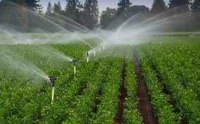With Sprinkler Irrigation field areas irrespective of their sizes can be covered efficiently.
* This irrigation method can be applied to all the types of soils since sprinklers with different discharge and outlet capacities are available on the market.

### 2. Drip irrigation

* Drip irrigation can be defined as the method in which water drips slowly via a pipe system to the roots of the plants either from above or below the soil surface.
* 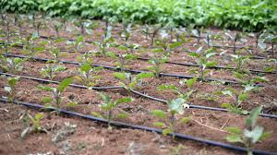It is also known as micro-irrigation by which both water and [soil nutrients](http://www.ugaoo.com/knowledge-center/essential-nutrients-for-plants/) can be saved.
* A set up of valves, tubes, pipes, and emitters is used for drip irrigation.
* The best part about drip irrigation is that valves and pumps can be operated both manually and automatically with the help of a controller.

### 3. Surface Irrigation

* Surface irrigation has been practiced and followed for many years now.
* It can be defined as a group of techniques where water is distributed over the surface of the soil gravity.
* In this type of irrigation, either the field is flooded (this is known as Basin Irrigation) or the water is fed into small channels (this is known as furrow irrigation).

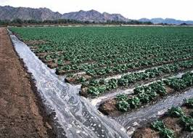

### 4. Basin Irrigation

* Basin Irrigation method is primarily used for crops that stand in water for more extended periods, flat lands where rice is grown or in terraces on hillsides.
* In Basin Irrigation flat areas of land are surrounded by low bunds. These bunds block the water and prevent it from entering the adjacent fields.
* Trees can also be grown using basin irrigation method.
* Basin irrigation is suitable pastures, citrus, banana and to some extent tobacco.
* This method cannot be used for crops that cannot stand waterlogged like potatoes, [beetroot](http://www.ugaoo.com/beetroot.html) and [carrots](http://www.ugaoo.com/desi-carrot-long-1000-seeds.html)
* The type of crop grown determines the soil suitable for basin irrigation
* Basin irrigation can be constructed on a flat surface, the easier it is to build basins, sloping land.
* Level basins, called terraces, can be constructed on steps of a staircase

. 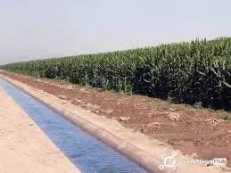 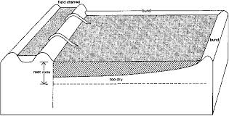

### 5. Furrow irrigation

* The application in which small channels carry water in between the crop rows and down the slope is known as Furrow irrigation.
* Furrow irrigation is preferable to row crops and the ones that cannot thrive waterlogging.
* Only [maize](http://www.ugaoo.com/sweetcorn-15-seeds.html), [sunflower](http://www.ugaoo.com/sunflower-miniature-single-2071.html), sugarcane, and soyabean can be irrigated via furrow irrigation.
* 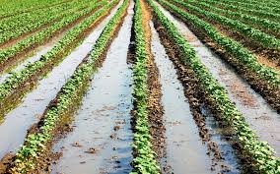While [Tomatoes](http://www.ugaoo.com/tomato.html), Potatoes, Beans, Citrus and Grape would be damages if grown with Furrow Irrigation.
* In this particular method of irrigation water flows from the field channel into the furrows by opening up the bank of the channel or by siphons or spiles.
* Furrows must determine the slope, type of soil, size of the stream, irrigation depth, and field length.
* It should be done on flat or gentle slopes; if done on undulating land, furrow irrigation should follow the land contouring method.